The Case Diagram of Buyer-Seller Interaction of the library. 3
4
5
The Sequence Diagram for Use Case 1 5
The Collaboration Diagram for Use Case 1 6
The Sequence Diagram for Use case 2 7
The Collaboration Diagram for Use Case 2 8

Object Oriented Methods Buyer Seller Project
\

Object-oriented design refers to a method for analyzing, designing a system by applying the object-orientated concepts. Moreover, it develops a set of graphical system models during the development life cycle of the software. A class diagram models the static structure of a system. Consequently, it shows relationships between classes, objects, attributes, and operations. Classes represent an abstraction of entities with common characteristics. Equally important, associations represent the relationships between classes.
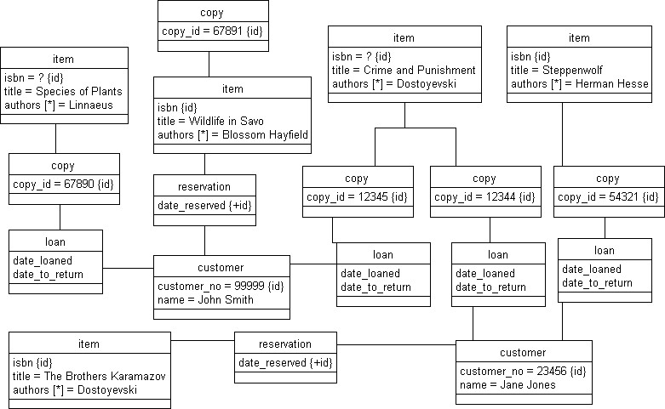

The Case Diagram of Buyer-Seller Interaction of the library.
The diagram below depicts several use cases, actors their associations. Consequently, this class diagram models a customer order from a retail catalog. A library collection consists of books and magazines. Besides, magazines are gathered into annual volumes. There may be many physical books of the same title. The library customers may search for works according to search words (writer, title, name, and number of a magazine). In addition, they may borrow books. Therefore, when a customer borrows a book, his/her name, the ID of the borrowed book, the date, and the due date are recorded. In addition, the customer may also make a reservation for a title that is not available at the moment. The reservation contains information on the customer, the title and the date of reservation. Magazines cannot be borrowed therefore they can only be read in the library.

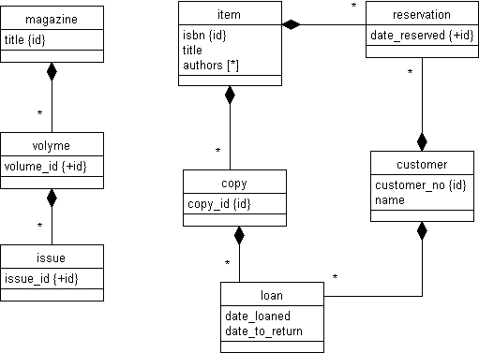
The diagram below represents a corresponding class diagram of the library. It describes the following things: John Smith (ID 99999) has borrowed two books: Dostoyevski's Crime and Punishment (ID 12345) and Linnaeus' Species of Plants (ID 67890) on 30th March 2000. At the same time, he has reserved the book Wildlife in Savo (67891), edited by Blossom Hayfield. Jane Jones has borrowed Herman Hesse's Steppenwolf (54321) and another copy of Dostoyevski's Crime and Punishment (12344).

Sequence diagrams are used to visualize the collaboration between objects and methods to perform a particular task.

The Sequence Diagram for Use Case 1

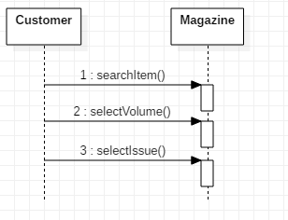
Magazines can only be read at the library. The customer searches for the magazine, selects the volume, then selects the issue.

The Collaboration Diagram for Use Case 1
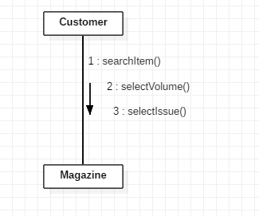

The Sequence Diagram for Use case 2
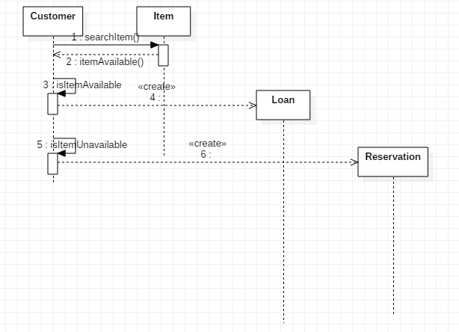
The customer searches for the item. The item object returns a value telling if the book is available or not. If the book is available, the customer creates a loan for the book. If the book is unavailable, the customer creates a reservation for the book.

The Collaboration Diagram for Use Case 2
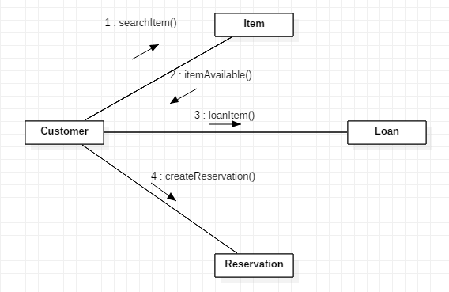
State-Transition Diagrams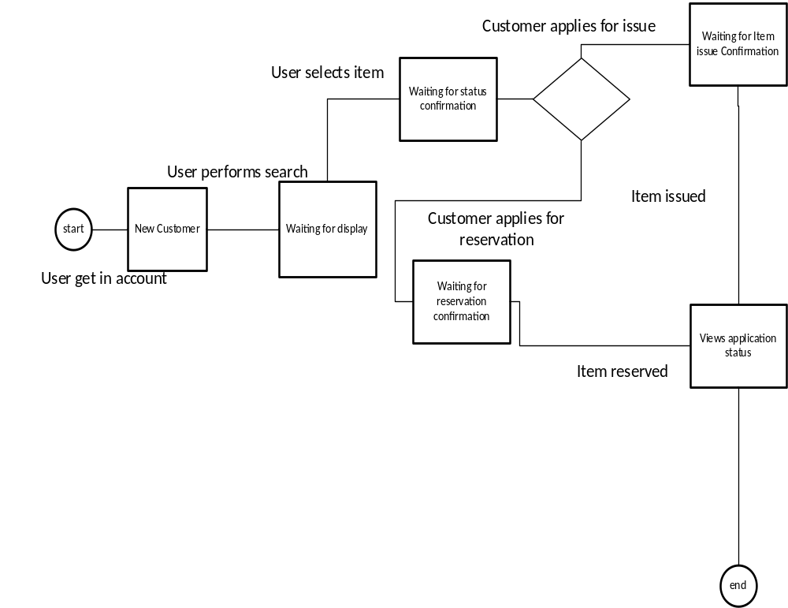

Activity Diagram
